# [Why become a Freemason](https://www.glosmasons.org.uk/what-freemasonry)?



**Freemasonry** has more than 200,000 members spread throughout England and Wales and worldwide. In total, we have more than 7,000 Lodges, with students over 18 able to join one of the 85 University Scheme Lodges. Women can join one of two female-only organizations: The Order of Women Freemasons and Freemasonry for Women.

**Freemasonry has a Long Tradition** and when you become a Freemason, you join a long tradition of great men in many fields who found inspiration and support in this organization, since it began in 1717. You are embraced into an organization that genuinely cares for each of its members and wants to see them excel and meet life’s challenges with strength and integrity. It can help to reach your potential.

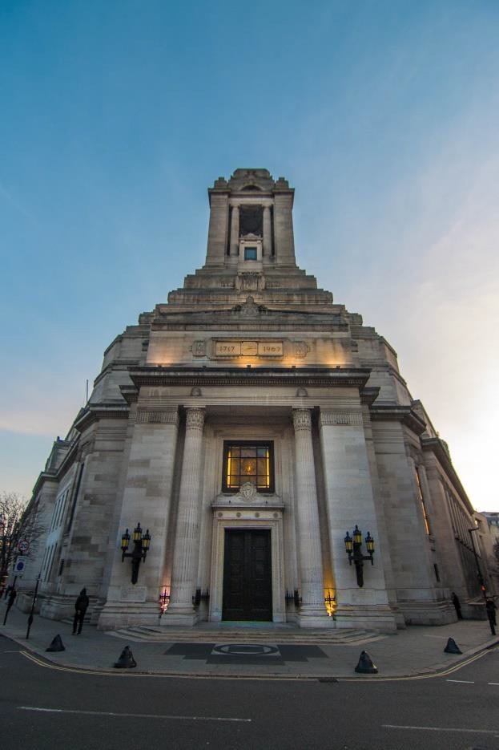

*Freemasons Hall London*

For those who are intrigued by its history and mysteries, you are welcome to visit, or explore on-line the impressive collection of pictures, sculptures, artifacts, documents and books available in the Library at Freemasons Hall. It has an extensive art and artifact collection, acquired over many centuries, which brings the history of Freemasonry to life.

**Freemasonry Encourages Interaction with Diverse Groups of People:** A lodge often has a diverse membership. Having no political or religious affiliations, we comprise members of all races, religions, cultures and backgrounds, range in age from 18 to 80 or older, and from a wide range of professions. You would not easily have access to such a broad range of people in most other areas of your life.

**Freemasonry is a Global Community** and once you become a Freemason, you can travel across the United Kingdom, and in many cases the World, meeting other Freemasons with whom you can connect with, find affinity, and take opportunities to broaden your own horizons.

# [What are the benefits of becoming a Freemason](https://www.glosmasons.org.uk/what-freemasonry)?

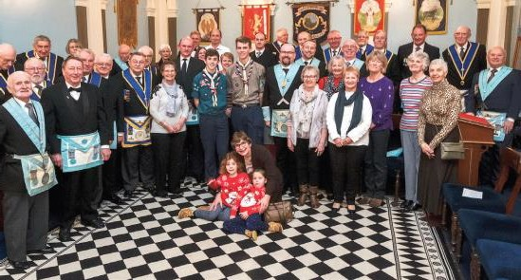[**Making New Connections:** Becoming a member of a](https://www.glosmasons.org.uk/what-freemasonry) lodge provides the opportunity to make new lifelong friends. It gives you that ‘local’ feeling where you can meet regularly to eat and drink, have fun and feel supported by a group of like-minded people sharing common values in a unique setting. ‘*I admire how inclusive Freemasonry is. We respect and welcome men from all walks of life. We are all friends working together to be happy and we encourage each other to be better people’* TONY OLD GLOBE LODGE

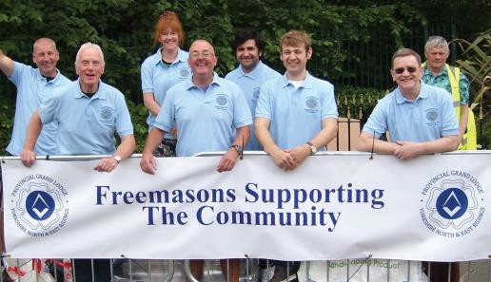**Community Involvement:** As a member of a lodge, you have the opportunity to get involved with your local community through charitable and social events. Fundraising and charity is at the heart of Freemasonry and getting involved provides you, your partners, family and friends the opportunity to connect with people locally and make a real difference to the lives of others. ‘*I chose Freemasonry as a hobby only to find that it offers so much more. The core principles of Freemasonry play a part in every one of my days. Freemasonry has enhanced my life in numerous ways’* DOUG DUNDAS LODGE

**Personal Development:** In Freemasonry you take part in interactive ‘plays, first as a passive participant before moving on to more active and involved roles. Along the way, you hear about, look at, contemplate, and describe various symbolic artifacts, learn the different levels of meaning behind them; all the while you practice the behavior’s you can implement in daily life. Our ceremonial traditions encourage us to be both more tolerant and respectful and to fulfill our civic responsibilities. *‘I particularly enjoy the seriousness of the ceremony, but I also enjoy the social aspect of Freemasonry, both during lodge meetings and at our special events with friends and family’.* BILL WILBERFORCE LODGE

**Freemasonry Activities Improve Your Confidence:** Many lodge activities provide opportunities to deliver impromptu or planned speeches, hold offices, and to think on your feet. Networking opportunities, learning from peers and mentors, and practicing lines for our ceremonies can help you to develop skills beneficial to both your professional and personal life.

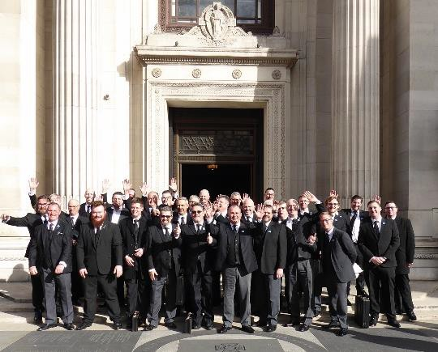**Freemasonry Provides Access to Intellectual Discussions and Talks.** Lodges provide regular opportunities to attend lectures on a broad range of topics. Sometimes these lectures focus on themes like integrity, charity, and leadership. There are also presentations and live-events, supported by learning circles and discussion groups viewable on-line or on Facebook and Facebook or WhatsApp. Not to mention Solomon, a free virtual learning resource used by over 40,000 Masons. *‘Light Blue masons on an Away-Day at Grand Lodge’.*

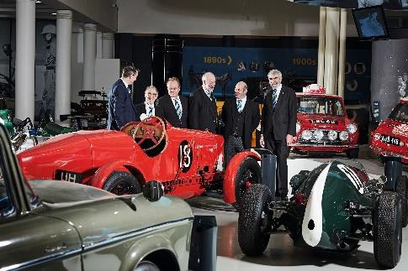**Special Interest Lodges.** Members can choose from a wide variety of special interest Lodges, formed by members to enjoy shared interests and can enrich the social calendar. For example, there are Fine Dining Lodges, Rugby Lodges, Cycling Lodges and Heritage Lodges to list but a few.

*‘Car Lodge - Credit Jude Edginton’.*